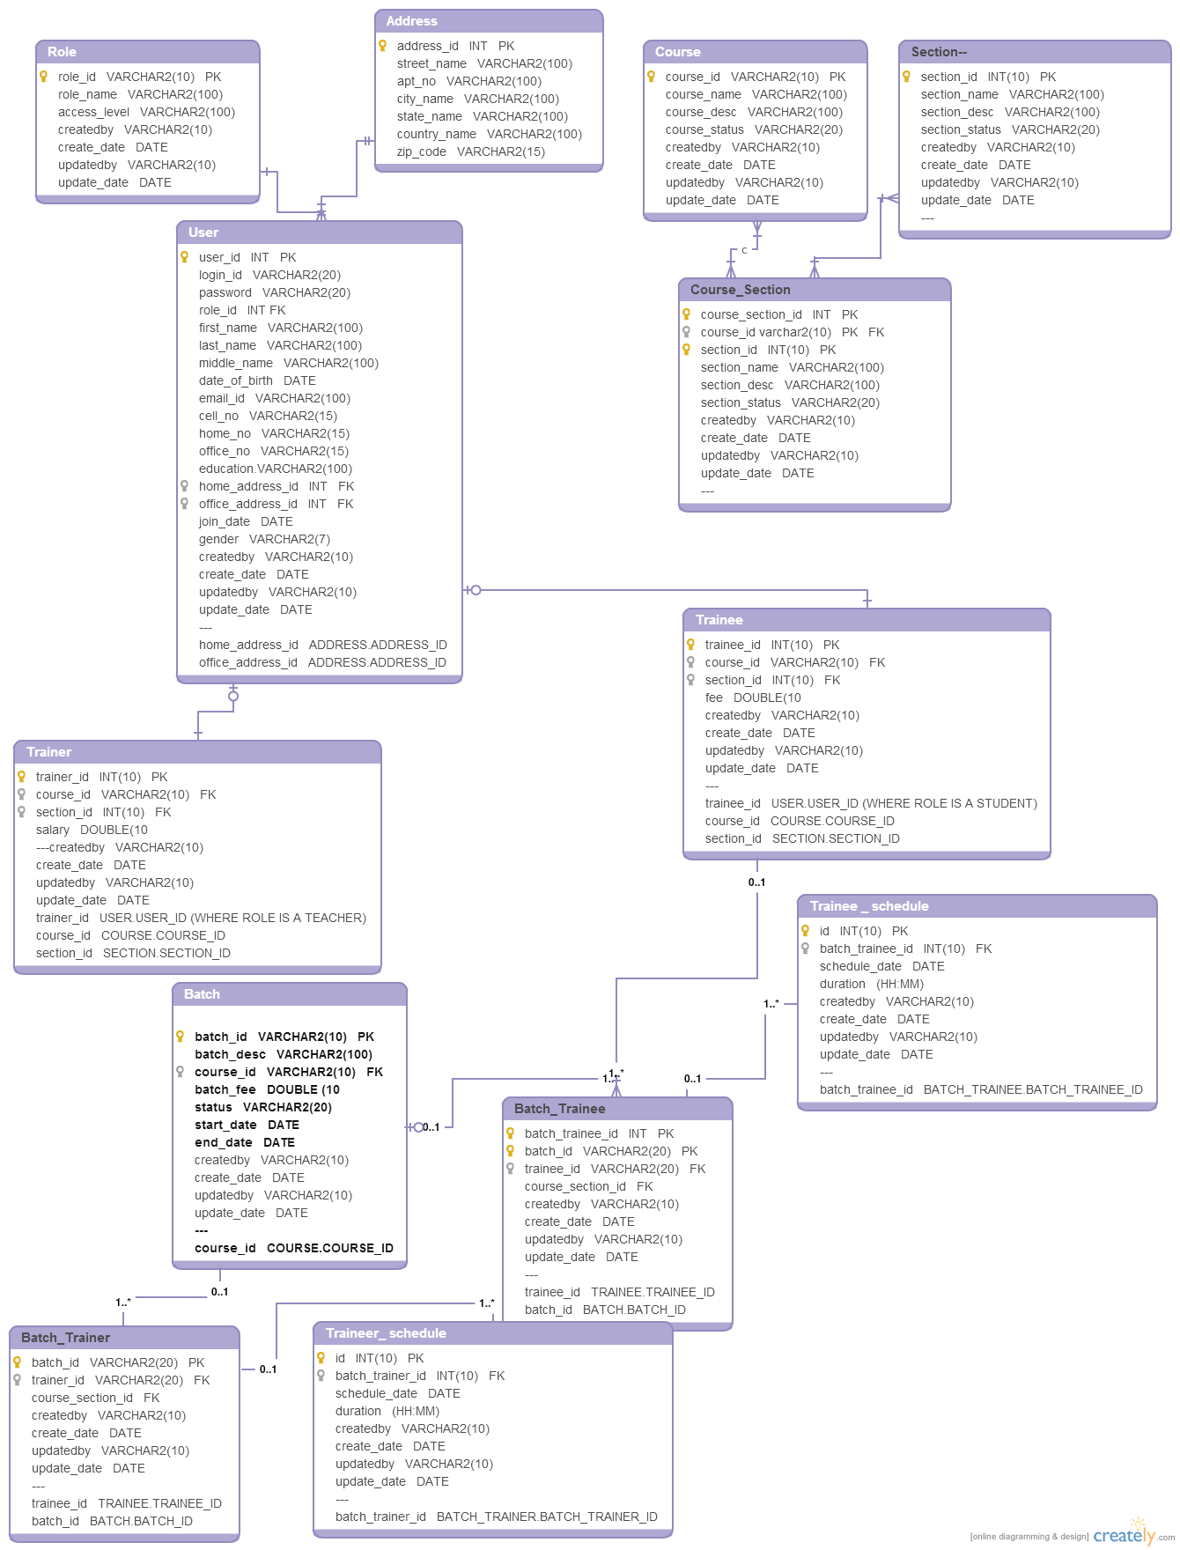

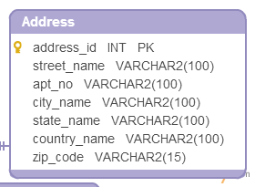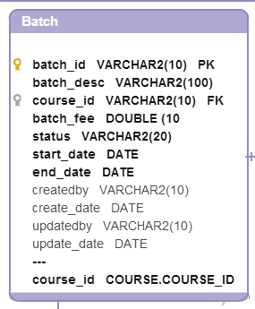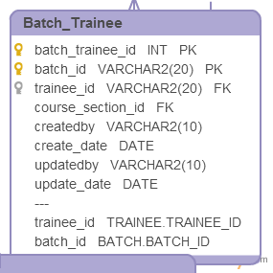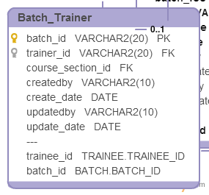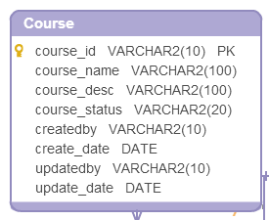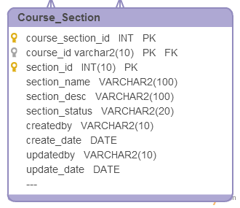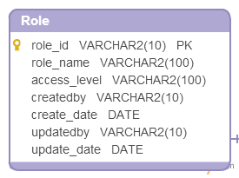

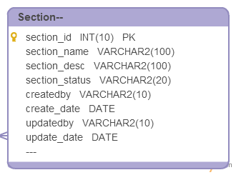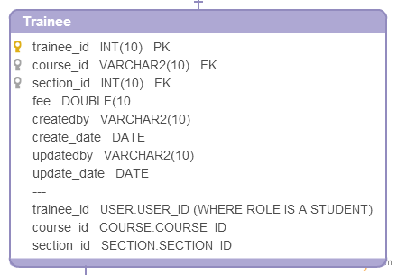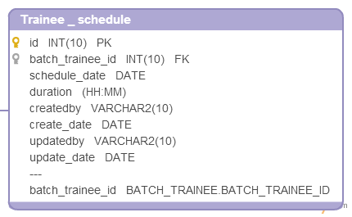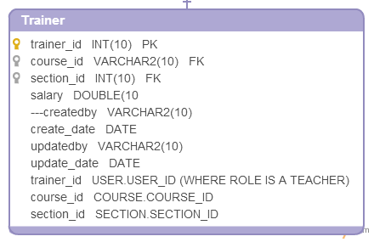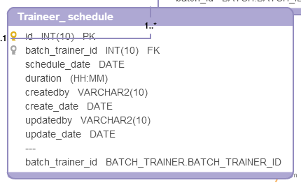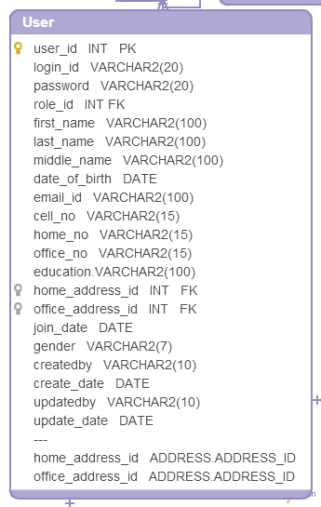

Table

1.**Role**

**Description**

**Table Name -Role**

|  |  |  |  |  |  |  |
| --- | --- | --- | --- | --- | --- | --- |
| Column Name | Type | Descriptive name | Valid Values | Index Column | Allow Nulls | Description |
| role_id | VARCHAR2(10) | ROLE ID | ADMIN,TEACHER,STUDENT |  | NO | This field is a unique alphanumeric identifier for the site.  This Identifier should be used by all data collectors for the site. |
| role_name | VARCHAR2(100) | Role Name | ADMIN,TEACHER,STUDENT |  | NO | This field is |